**Results**

We ran our code for male images and females. We have shown below the outputs we received for different age groups.

Male:

Female: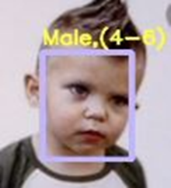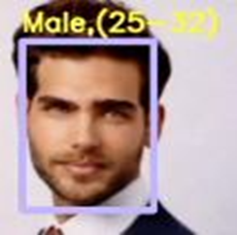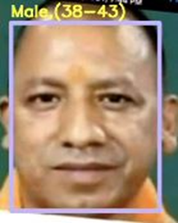

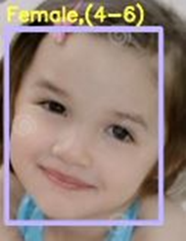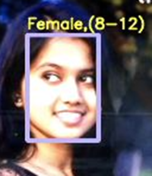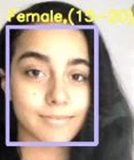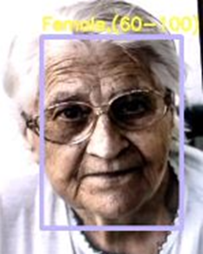

When the program recognizes a face, the following output is generated continually. When a face is not recognized, it prints “Face not found” If a face is detected, it returns something similar to (720, 1280, 3), where 720 is image height, 1280 is image width, and 3 is the number of channels: the number of components used to represent a pixel which is red, green, and blue.